Computer Engineering Department - ITU
CE101L: Object Oriented Programming Lab

Course Instructor: Usama Bin Shakeel | Dated: 28/04/2022
Teaching Assistant: Aqsa Khalid | Semester: Spring 2022
Lab Engineer: Nadir Abbas | Batch: BSCE2021

Lab 8B. Use of Static Variable and Singleton in Classes and Objects

Name | Roll number | Report  (out of 100) | Scaled to 10 | Total  (out of 10)
Muhammad Abubakar Saif | BSCE21017

Checked on: ____________________________

Signature: ____________________________

Objective
The objective of this lab is to observe the basic knowledge of programming classes in C++.

Equipment and Component
Component Description | Value | Quantity
Computer | Available in lab | 1

Conduct of Lab
- Students are required to perform this experiment individually.
- In case the lab experiment is not understood, the students are advised to seek help from the course instructor, lab engineers, assigned teaching assistants (TA) and lab attendants.

Theory and Background
In object-oriented programming, there is also the concept of a static member variable, which is a "class variable" of a statically defined class, i.e., a member variable of a given class which is shared across all instances (objects), and is accessible as a member variable of these objects.

In object-oriented programming, a singleton class is a class that can have only one object (an instance of the class) at a time. After the first time, if we try to instantiate the Singleton class, the new variable also points to the first instance created.

Lab Task

Task A: Static Variable inside of Class [Marks: 20]
In this task, you are required to create a class NumberIncrement with the following data members and member functions,

Private Static Data Members of class NumberIncrement such as:
count (static int)

Public Member Functions of class NumberIncrement such as:
void increment_count() – It will increment static data member.

Public Static Member Functions of class NumberIncrement such as:
static void print() – It will print static data member.

Create a UML diagram.

UML Diagram:
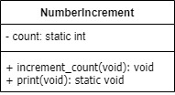

Initialize static data member

Do the following operations in main function:

1. Create object of class and call member function void increment_count().

2. Access static function directly with class name.

(Header File):
#include <iostream>
class NumberIncrement {
private:
static int count; //static int variable
public:
void increment_count() { //It will increment static data member.
count++; //increments the statin int variable
return;
}
static void print() { // It will print static data member.
std::cout << "Count: " << count << std::endl; //prinys the variable
return;
}
};

(Main Function):

int NumberIncrement::count = 0; //initialize the static variable to ZERO

int main {
NumberIncrement num; //declares the instance of class
num.increment_count(); //calls method of the class
NumberIncrement::print(); //directly calls the static function from main function via Classname
return 0; //breaks the casee
}

Output:
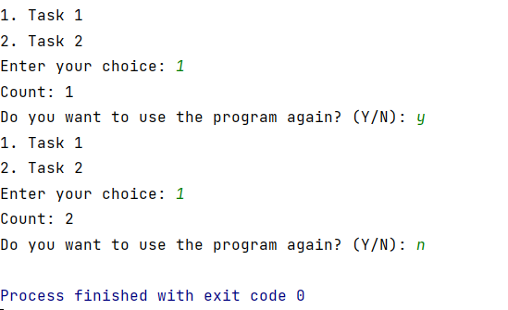
Task B: Singleton Design Pattern [Marks: 20]
In this task, you are required to create a class Singleton with the following data members and member functions,

Private Data Members of class Singleton such as:
data(int)
*instance(static Singleton)

Private Member Functions of class Singleton such as:
PrivateConstructor() – It will initialize data to zero.

Public Member Function of class Singleton such as:
static Singleton *getInstance() {
if (!instance)
instance = new Singleton;
return instance;
}
int get() – It will return data. e.g. return this->data;
void set() – It will set data. e.g. this->data = data;

Create a UML diagram.

Initialize pointer to zero so that it can be initialized in first call to getInstance
e.g. Singleton *Singleton::instance = 0;

Do the following operations in main function:

1. Create pointer *s of class Singleton that points to getInstance() method e.g. Singleton *s = s->getInstance();

2. Call get() method with pointer and display the result.

3. Set value of data using set(int)

4. Call get() method again with pointer and display the result.

UML Diagram:
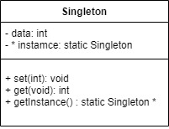

Code:
(Header File):
class Singleton {
private:
int data; //declares variable of int-type
static Singleton *instance; //declares static pointer of manually-declared type
Singleton() { //private constructor so that it can't be accessed on every call
data = 0; //sets the value of data to ZERO
}
public: //public methods
static Singleton *getInstance() { //assigns a new memory to the member pointer
if (!instance) //if instance already exists, it will not be re-declared
instance = new Singleton; //allocates new memory to the pointer
return instance; //returns the pointer
}
void releasesMem(){
delete[] instance; //releases the memory which is dynamically allocated
}
void set(int data){ //sets the value of private member
this->data = data;
return;
}
int get(){ //get the value of private member through this function
return this->data; //return value of 'data' to invoker function
}
};

(Driver Function):
Singleton *Singleton::instance = 0; //sets the pointer to ZERO so that pointer will be directed to new allocated memory in first call

int main {
Singleton *pnt = (*pnt).getInstance(); //declares the pointer of manually-declared type and directs it to existing instance
int val; //declares variables of int-type
val = pnt->get(); //gets the value of private member of class
cout << "data: " << val << endl; //prints the value
cout << "Enter the value you want to set for 'DATA' (private) variable: ";
cin >> val; //takes input from the user
pnt->set(val); //sets the value by calling method of class through pointer
cout << "New Value of 'DATA' (private) variable: " << pnt->get() << endl; //get and prints the value
return 0;
}

Output:
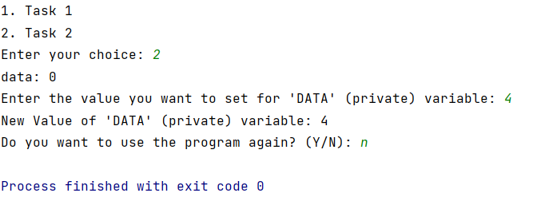

Assessment Rubric for Lab
Method for assessment:

Lab reports and instructor observation during lab sessions. Outcome assessed:
a. Ability to conduct experiments, as well as to analyze and interpret data (P) b. Ability to function on multi-disciplinary teams (A)
c. Ability to use the techniques, skills, and modern engineering tools necessary for engineering practice (P)
Performance metric | Task | CLO | Description | Max marks | Exceeds expectation | Meets expectation | Does not meet expectation | Obtained marks
1. Realization of experiment (a) | 1 | 1 | Functionality | 40 | Executes without errors excellent user prompts, good use of symbols, spacing in output. Through testing has been completed (35-40) | Executes without errors, user prompts are understandable, minimum use of symbols or spacing in output. Some testing has been completed (20-34) | Does not execute due to syntax errors, runtime errors, user prompts are misleading or non-existent. No testing has been completed (0-19)
2. Teamwork (b) | 1 | 3 | Group Performance | 5 | Actively engages and cooperates with other group member(s) in effective manner (4-5) | Cooperates with other group member(s) in a reasonable manner but conduct can be improved (2-3) | Distracts or discourages other group members from conducting the experiment (0-1)
3. Conducting experiment (a, c) | 1 | 1 | On Spot Changes | 10 | Able to make changes (8-10) | Partially able to make changes (5-7) | Unable to make changes (0-4)
 | 1 | 1 | Viva | 10 | Answered all questions (8-10) | Few incorrect answers (5-7) | Unable to answer all questions (0-4)
4. Laboratory safety and disciplinary rules (a) | 1 | 3 | Code commenting | 5 | Comments are added and does help the reader to understand the code (4-5) | Comments are added and does not help the reader to understand the code (2-3) | Comments are not added (0-1)
5. Data collection (c) | 1 | 3 | Code Structure | 5 | Excellent use of white space, creatively organized work, excellent use of variables and constants, correct identifiers for constants, No line-wrap (4-5) | Includes name, and assignment, white space makes the program fairly easy to read. Title, organized work, good use of variables (2-3) | Poor use of white space (indentation, blank lines) making code hard to read, disorganized and messy (0-1)
6. Data analysis (a, c) | 1 | 4 | Algorithm | 20 | Solution is efficient, easy to understand, and maintain (15-20) | A logical solution that is easy to follow but it is not the most efficient (6-14) | A difficult and inefficient solution (0-5)
7. Computer use (c) | 1 | 2 | Documentation & GitHub Submissions | 5 | Timely (4-5) | Late (2-3) | Not done (0-1)
 | Max Marks (total): |  |  | 100 | Obtained Marks (total):

Lab Engineer Signature: ________________________

